Greg Heitman

Dr. Pulimood

CSC 415-01

5 April, 2016

Assignment 4: Design User Interfaces (Updated)

Interface design mockups

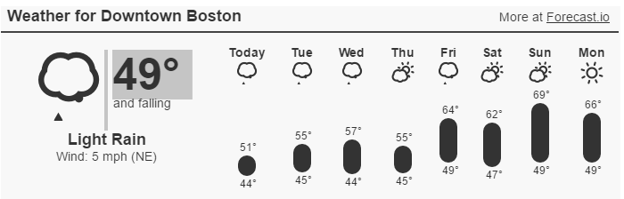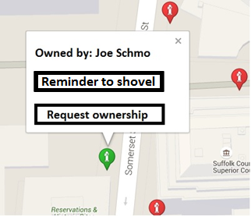

An email notification was sent to owner Joe Schmo!



Adherence to Eight Golden Rules of Interface Design

1. Strive for consistency

* Each hydrant on the Google Maps interface is color coded to indicate its ownership status.
* Each hydrant displays identical dialogue boxes with identical options to give users a consistent interface to interact with

2. Enable frequent users to use shortcuts

* Users who would like to request ownership can do so directly from the hydrant dialogue page if they have a hydrant that they already know they would like to request ownership of.

3. Offer informative feedback

* Upon selecting “request ownership”, a pop-up will provide feedback in the form of a visual notification, affirming to the user that their request has been processed

4. Design dialogs to yield closure

* Dialogue boxes flash on the screen when a user sends a reminder to shovel or requests ownership of a hydrant, notifying them that their request was processed and executed succesfully

5. Offer simple error handling

* There are no places where a user would errantly click and perform an undesired action on the simple interface that I have designed

6. Permit easy reversal of actions

* Users can simply select “Abandon this hydrant” to discard a hydrant that they no longer wish to own

7. Support internal locus of control

* Users are given the power to update their user information and credentials themselves, and are given the power to freely select a hydrant for their personal responsibility

8. Reduce short-term memory load

* Users don’t need to memorize any passwords or sequences to request ownership of hydrants or check the weather